A MINI PROJECT REPORT
On
Face Recognition Attendance Management System

Submitted by

Abhishek Sharma Deepak Raj
Roll No:161500023 Roll No:161500187

Ashish Varshney Ayush Goel
Roll No:161500143 Roll No:161500157

To
Ms Ambika Gupta

Department of Computer Engineering & Applications
Institute of Engineering & Technology



GLA University
Mathura- 281406, INDIA
December, 2018
Department of Computer Engineering and Applications
GLA University, Mathura
17 km. Stone NH#2, Mathura-Delhi Road, P.O. – Chaumuha,
Mathura – 281406

Declaration
We hereby declare that the work which is being presented in the Mini Project “Face Recognition Attendance Management System”, in partial fulfillment of the requirements for Mini-Project LAB, is an authentic record of our own work carried under the supervision of Ms. Ambika Gupta, Assistant Professor, GLA University, Mathura.

Abhishek Sharma Ashish Varshney
Sign:_________ Sign:__________

Ayush Goel Deepak Raj
Sign:_________ Sign:__________

Department of Computer Engineering and Applications
GLA University, Mathura
17 km. Stone NH#2, Mathura-Delhi Road, P.O. – Chaumuha,
Mathura – 281406

CERTIFICATE

This is to certify that the project entitled “Face Recognition Attendance Management System” carried out in Mini Project – ILab is a bonafide work done by Abhishek Sharma(161500023), Ashish Varshney(161500143),Deepak Raj(161500187) and Ayush Goel(161500157)and is submitted in partial fulfillment of the requirements for the award of the degree Bachelor of Technology (Computer Science & Engineering).

Signature of Supervisor:
Name of Supervisor:
Date:

ACKNOWLEDGEMENT

It gives us a great sense of pleasure to present the report of the B. Tech Mini Project undertaken during B. Tech. Third Year. This project in itself is an acknowledgement to the inspiration, drive and technical assistance contributed to it by many individuals. This project would never have seen the light of the day without the help and guidance that we have received.

Our heartiest thanks to Dr. (Prof). Anand Singh Jalal, Head of Dept., Department of CEA for providing us with an encouraging platform to develop this project, which thus helped us in shaping our abilities towards a constructive goal.

We owe special debt of gratitude to Ms. Ambika Gupta, Assistant Professor Department of CEA, for his constant support and guidance throughout the course of our work. His sincerity, thoroughness and perseverance have been a constant source of inspiration for us. He has showered us with all his extensively experienced ideas and insightful comments at virtually all stages of the project & has also taught us about the latest industry-oriented technologies.

We also do not like to miss the opportunity to acknowledge the contribution of all faculty members of the department for their kind guidance and cooperation during the development of our project. Last but not the least, we acknowledge our friends for their contribution in the completion of the project.

Abhishek Sharma
Ashish Varshney
Deepak Raj
Ayush Goel

Abstract

In this paper, we advise a method that takes the presence of students for classroom lecture. Our method takes the presence automatically using face recognition. However, it is complicated to calculate approximately the attendance exactly using each result of face detection independently because the face recognition rate is not sufficiently high. In this paper, we propose a process for estimate the presence precisely using all the results of face recognition obtained by Continuous inspection. Continuous inspection improves the performance for the estimation of the presence we Constructed the lecture presence system based on face recognition, and applied the system to classroom lecture. Face recognition technology has widely concerned concentration due to its huge application value and market potential, such as face recognition and video observation system. Real-time face detection not only is one part of the automatic face recognition system but also is increasing an independent research subject. So, there are lots of approaches to solve face detection. This paper describes the expansion of a student attendance system based on face recognition and authentication technology. Python OpenCV outline is used for implementation. The existing conventional presence system requires students to manually sign the sheet every time.

Table of Contents
Declaration ii
Certificate iii
Acknowledgments iv
Abstract v

Table of Contents vi

- Introduction 1
1.1 Current Systems ………………………………....................................................1
1.2 Motivation .…………………………………………………................................1
1.3Scope…………………………………………………………………………….1
1.4 Drawbacks in existing system…………………………………………………..2
1.5 Project Plan……………………………………………………………………...2
1.5.1 Objective…………………………………………………………………....2
1.5.2 Goals…………………………………………………………………….….2

- Software Requirement Analysis 3
2.1 General Description……………………………………………………………..3
2.2 Product Perspective……..………………………………………………………...….3
2.3Proposed Solution……………………………………………………………..….4
2.4Proposed System Components…………………………………………………....4
2.5Proposed System Outcomes………………………………………………………4
2.6Contribution………………………………………………………………………5.
2.7 Specific Requirements…………………………………………………………...5
2.7.1 External Interface Requirements………………………………………….…5
2.7.1.1 User Interfaces………………………………………………………….5
2.7.1.2 Hardware Interfaces…………………………………………………….5
2.7.1.3 Software Interfaces……………………………………………………...5
2.7.1.4 Communication Interface……………………………………………….6
2.8 Functional Requirements………………………………………………………....6
- Software Design 7
3.1 Use Case ……………………….………………………………………………7-8
3.2 Data Flow Diagrams………………………………………………………………9-12
3.3 Logical Database Requirements…………………………………………………13

- Testing 14
  - Introduction………….……………………………………………………………. 14
  - Content Review……………………………………………………………………14
  - Navigation Errors………………………………………………………………….14
  - White- Box Testing………………………………………………………………..14
  - Black Box Testing…………………………………………………………………15
- Implementation and User Interface 16
  - FRAS Screens …………………………….........................................................16-22
6. References/Bibliography 23
Appendices 24-37

Chapter 1

1. Introduction
The Attendance Management System has become an important factor in the education field. This system should help the professors and lecturers in marking the attendance by reducing their effort and the time consumption. The study findings enables the definition of the project problem statement, its objectives, scope and advantages of the Face Recognition Attendance Management System.
1.1 Current Systems
At present attendance marking involves manual attendance on paper sheet by professors and teachers but it is very time consuming process and chances of proxy is also one problem that arises in such type of attendance marking. Also there are attendance marking system such as RFID (Radio Frequency Identification), Biometrics etc. but these systems are currently not so much popular in schools and classrooms for students. So, why not shift to an automated attendance system which works on face recognition technique? Be it a class room or entry gates it will mark the attendance of the students, professors, employees, etc.
1.2 Motivation
The main motivation for us to go for this project was the slow and inefficient traditional manual attendance system. These made us to think why not make it automated fast and much efficient. Also such face detection techniques are in use by department like crime investigation where they use CCTV footages and detect the faces from the crime scene and compare those with criminal database to recognize them.
1.3 Scope
The scope of the system is to have a high-tech environment in the GLA University. That means by using the face recognition attendance management system, the university will transfer to the technical attendance system from a traditional attendance system. This system will add some features in the dynamic classroom management system of our university by marking the attendance of every student using the image processing and computer vision technology in every classroom at GLA University. That will help the university use the technology in effective ways:
- Make the attendee process easier and effective.
- Help faculty in the attendance process every time.
- Mange and organize the attendance data of every student.

1.4 Drawbacks in existing system
- These attendance systems are manual
- There is always a chance of forgery (one person signing the presence of the other one) Since these are manual so there is great risk of error
- More man-power is required (some person to take attendance)
- Calculations related to attendance are done manually (total classes attended in month) which is prone to error. It is difficult to maintain database or register in manual systems
- It is more costly (price of register, pen and the salary of person taking attendance)

1.5 Project Plan
1.5.1 Objective
- Detection of unique face image amidst the other natural component such as walls and other backgrounds.
- Detection of faces amongst other face characters such as beard, spectacles etc.
- Extraction of unique characteristic features of a face useful for face recognition.
- Effective recognition of unique faces in a class (individual recognition).
- Automated update in the attendance sheet without human intervention.

1.5.2 Goals

- To help the lecturers, improve and organize the process of track and manage student attendance.
- Provides a valuable attendance service for both teachers and students.
- Reduce manual process errors by provide automated and a reliable attendance system.
- Increase privacy and security which student cannot present him or his friend while they are not.
- Produce monthly reports for lecturers.
- Flexibility, Lectures capability of editing attendance records.

Chapter 2

Software Requirement Analysis

  - General Description

Over the past decade, taking down student’s attendance process had been developed and changed. The driven force of this development is the desire to automate, facilitate, speed up and save time and efforts. Although that the attendance systems are around us everywhere, GLA University lecturers still use a traditional way to record students’ attendance through calling out students’ roll numbers. This way is time consuming and associated with high error scales. In this project, we attempt to reduce wasted time, eliminate buddy clocking, and automate the process. Our system uses facial recognition technology to record the attendance through a high resolution digital camera that detects and recognizes faces and compare the recognize faces with students’ faces images stored in faces database.
Once the recognized face matches a stored image, attendance is marked in attendance database for that person. The process will repeat if there are missed faces. For example, if there are 4 faces missed for a bad position while the detecting phase, then this phase will start again to detect the missed faces and recognize them and continue the attending process. By the end of the month, a monthly report is send to the lecturer contains attendance and absence rates as a chart and the names of absentees. Also, a warning message sends to the student if he passes the allowed number of absence.

2.2 Product Perspective

This product Face Recognition Attendance Management System depends on the vast database of GLA University for the records of the students. The product will automate the various task associated with handling student details, surveillance inside the class and optimum performance thus helping the college authorities to ensure the smooth working of these processes.

2.3 Proposed Solution

To overcome the problems in existing attendance system we shall develop a Biometric based attendance system over simple attendance system. There are many solutions to automate the attendance management system like thumb based system, simple computerized attendance system but all these systems have limitations over work and security point of view. Our proposed system shall be a “Face Recognition Attendance System” which uses the basic idea of image processing which is used in many secure applications like banks, airports etc.

2.4 Proposed System Components
Following are the main components of the proposed system
- Student Registration
- Face Detection
- Face Recognition
- Feature Extraction
- Feature Classification
- Attendance management system
It will allow uploading, updating and deletion of the contents of the system.
Attendance management will handle:
- Automated Attendance marking
- Manual Attendance marking
- Attendance details of users.

2.5 Proposed System Outcome
- System will only allow authenticated user to login to the system and/or make changes to it.
- It will allow user to mark attendance of the students via face recognition technique.
- It will detect faces via webcam and then recognize the faces.
- After recognition it will mark the attendance of the recognized student and update the attendance record.
- The user will be able to print these record details afterward.

2.6 Contribution
Face recognition is the most natural biological features recognition technology according to the cognitive rule of human beings; its algorithm is ten times more complex than a fingerprint algorithm. Face recognition is featured by the following advantages compared to fingerprint:
->Accurate and Fast Identification
->High Usability and Security
->User friendly design

2.7 Specific Requirements

2.7.1 External Interface Requirements

2.7.1.1 User Interfaces

- GUI along with the meaningful frames and buttons.
- Reports are generated as per the requirement.

2.7.1.2 Hardware Interfaces

Hardware Requirement | Core 2 Duo 2nd generation
System Configuration | RAM – 2 GB DDR – 3
Operating System | Windows – 7/8/8.1/10
Other hardwares | D3D D8801 Home Security Camera (128 GB, 1 Channel)

2.7.1.3 Software Interfaces
Front End | Python
Back End | Python ,Open CV

2.7.1.4 Communication Interface

The machine will have to be the part of the Local Area Network to access central database.

2.8 Functional Requirements

The functional requirements that our product Face Recognition Attendance Management System will fulfill are given below.
- Taking and tracking student attendance by facial recognition in specific time.

- Sending the names of the absent student directly to the lecturer

- Permitting the lecturer to modify the student absent or late.

- Showing the names of who is absent or late in the screen to avoid errors.
Chapter 3

Software Design
3.1 Use Case
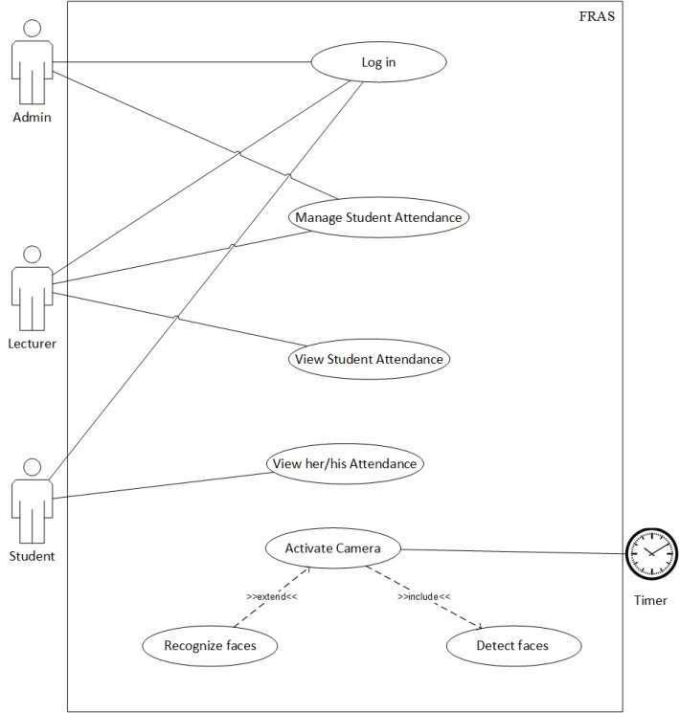

As shown in the use case diagram, the FRAS has actors named Admin, Lecturer and Student which are the main users of the system. Other actor, timer which turns camera on to record attendance by detecting and recognizing faces.

3.1.1 Use Case Description (Detailed Use Cases)

Log in
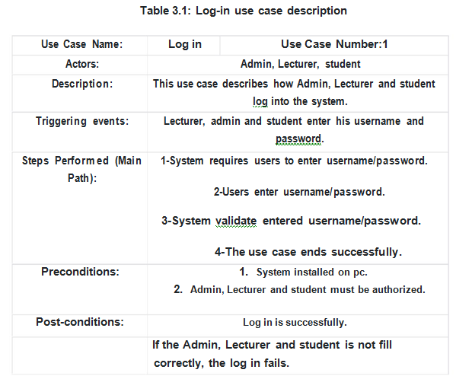

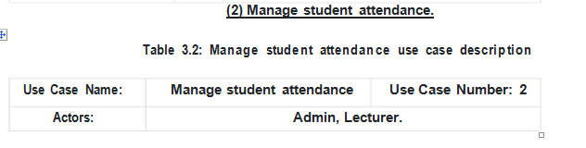

3.2 Data Flow Diagrams

Level 0
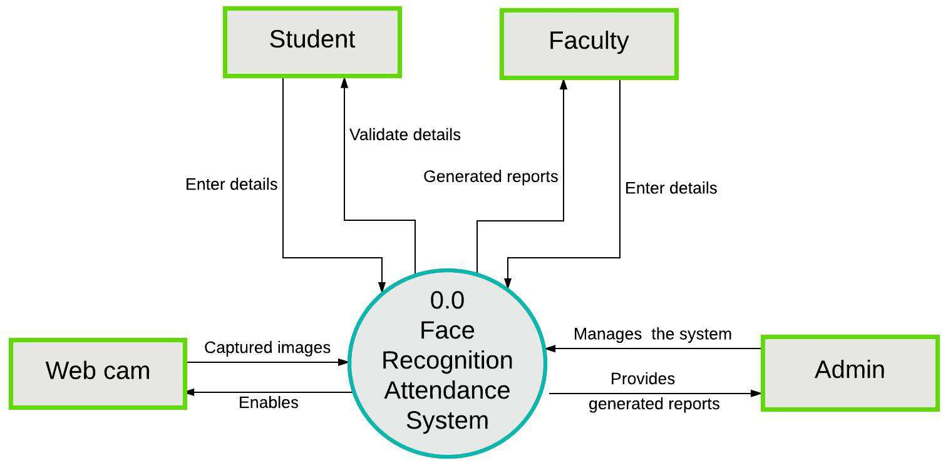

Level 1
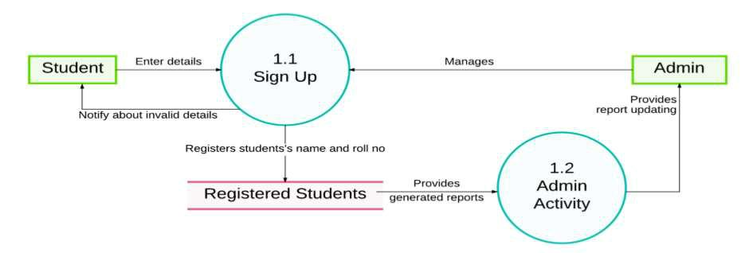

Student Registration Flow

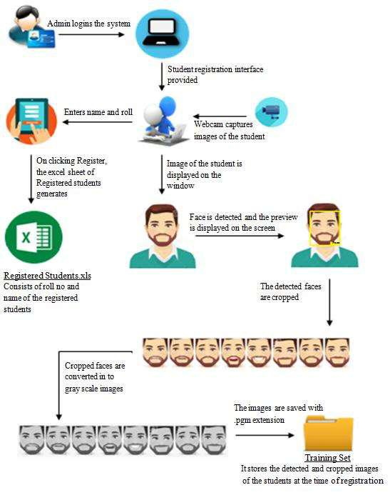

Figure 1: Student Registration Flow

Attendance Flow

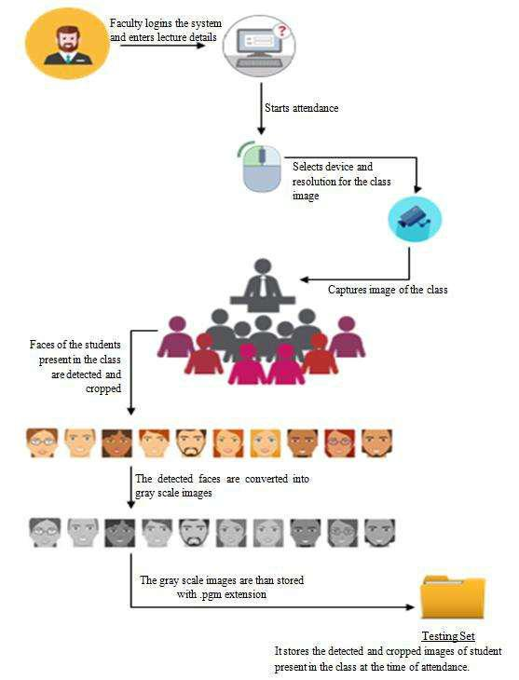

Figure 2 Taking Attendance Flow

Generating Attendance Flow
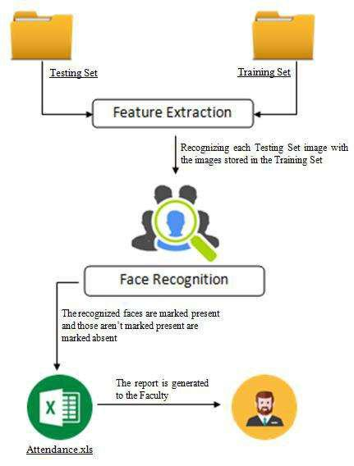

Figure 3 Generating Attendance Flow

3.3 Logical Database Requirements

Logical classification of data entities as well as their attributes.

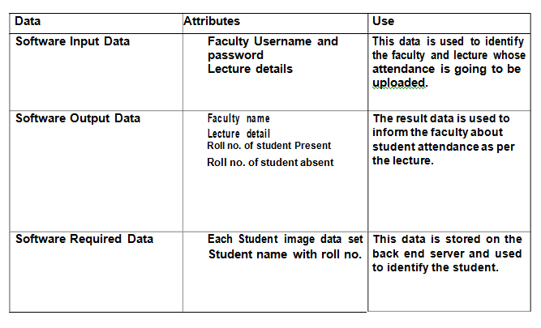

Chapter 4

Testing

4.1Introduction
System Development is a process of conceiving the specification specified in the designing stage into source code. Testing is the process of exercising software with the intent of finding errors and ultimately correcting them. The following testing techniques have been used to make this project free from errors.
4.2 Content Review
The whole content of the project has been reviewed thoroughly to uncover grammatical errors and ambiguous sentences.
4.3 Navigation Errors
Different users were allowed to navigate through the projects to uncover the navigation errors. The views of the user regarding the navigation flexibility and user friendliness were taken into account and implemented in the project.
4.4 White-Box Testing
White-Box Testing (also known as clear testing,structural testing and glass-box testing) tests internal structures or working of a program , as opposed to the functionality exposed to the end-users.
In white-box testing an internal logical path through the software are tested by providing test cases that exercise specific set of conditions and loops.
Using white box testing software development can derive test case that
- Guarantee that all independent paths within a module have been exercised at least once.
- Exercised internal data structure to ensure their validity.
- Exercise all loops at their boundaries and within their operational bound.

4.5 Black Box Testing

Black-box testing is a method of software testing that examines the functionality of an application without peering into its internal structures or working. This method of test can be applied to virtually every level of software testing: unit, integration, system & acceptance.

Chapter 5

Implementation and User-Interface
5.1 FRAS Screen:

This is the first GUI page of FRAS (Face Recognition Attendance System ) in which login option is shown by clicking on the login button we enter in the next page.

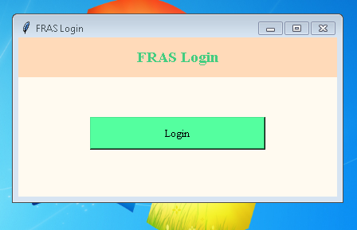

- This is the next page where the user after login have to enter the user name and password.
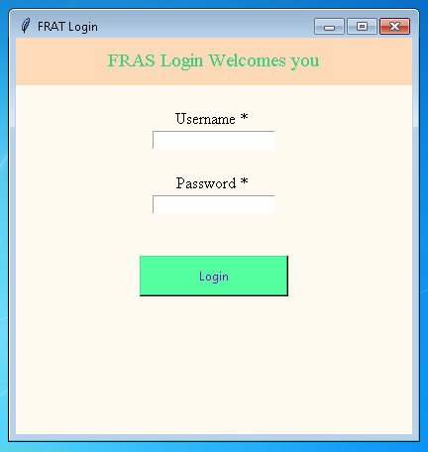
- After successful login Welcome screen of FRAS which shows course, branch, year ,section which is allotted to the lecturer. It also contains logout button to come back to the login page .

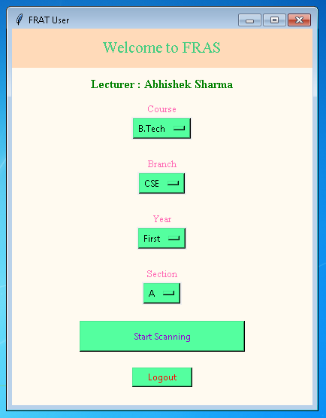
- This is how the scanning of face is seen .
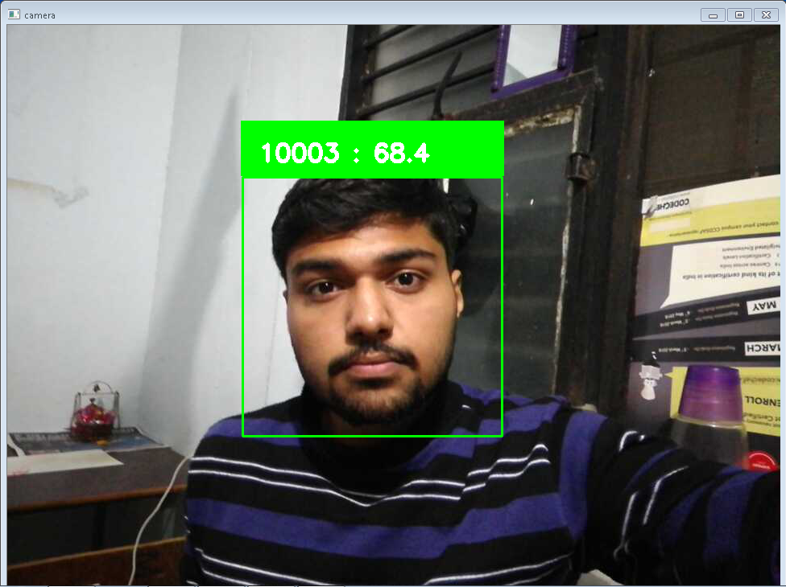

- After scanning the faces of all the present student Attendance sheet will be generated in which we can modify the attendance last time before saving the attendance.

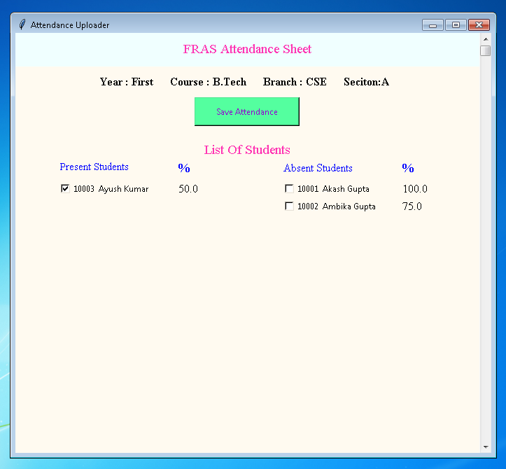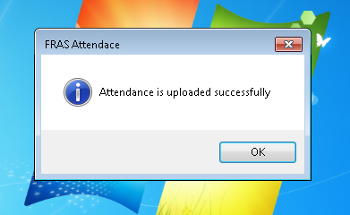

- Admin control panel page
Admin can create training model for face recognition algorithm from the dataset created by Generate dataset and admin can also provide a access to any faculty who want to take attendance by creating their user ID and password.
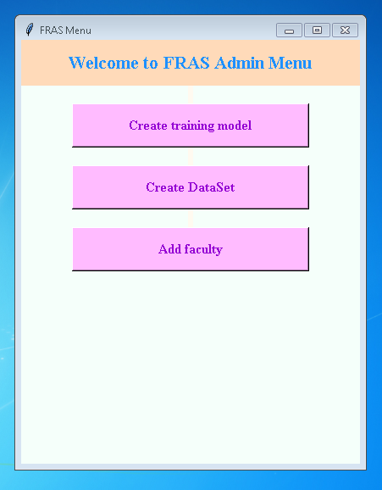

- FRAS Trainer page
This will get the dataset from specific location and generate training model using LBPH algorithm and save at specific location by the name trainer.yml.

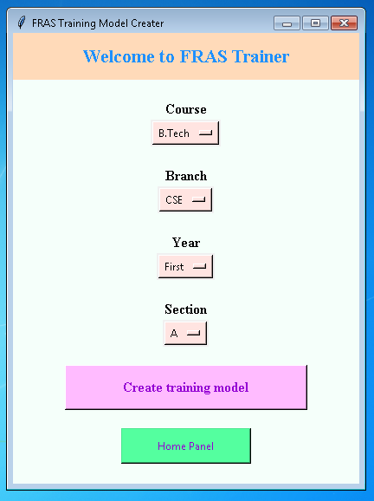
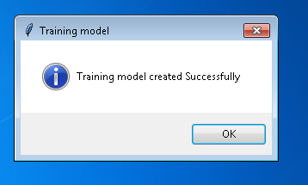
- FRAS Faculty Access page
This login page will create new user and delete old user

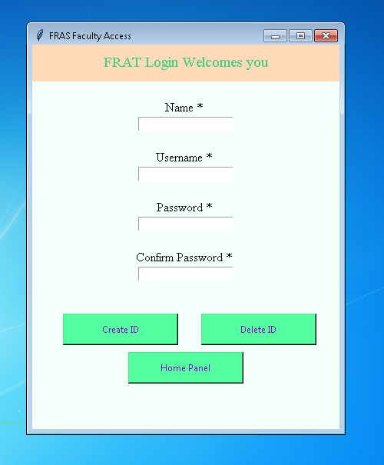

- FRAS Database

It consist of three table named as access, attendance and student
Access table store the name, user ID , password for Admin and faculty.
Student table store the name of students, ID of student,
Attendance table store the date and attendance of students.

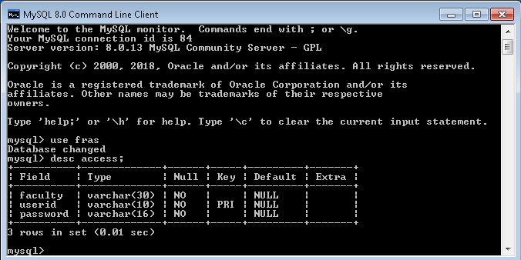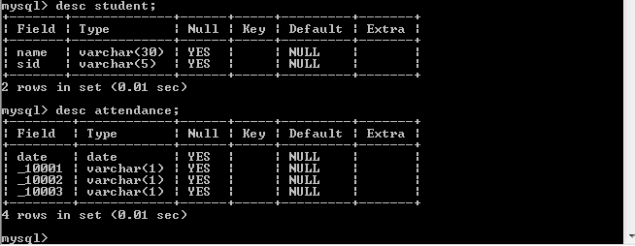

Chapter 6

References/Bibliography

Book:
Learning Open CV 3 Computer Vision with Python by Joe Minichino and Joseph Howse
Learing python by Mark Lutz, David Ascher

Websites:
- Diepen, G. (2017). Detecting and tracking a face with Python and OpenCV. Available at https://www.guidodiepen.nl/2017/02/detecting and-tracking-a-face-with-python-and-opencv/
- https://docs.opencv.org/3.0-beta/doc/py_tutorials/py_tutorials.html
- https://www.tutorialspoint.com/python/python_gui_programming.htm

Chapter 7

Appendices

Code:
#Login Page for Faculty
import mysql.connector
import tkinter as tk
from tkinter import messagebox
import faceRec
def faculty(screen):
screen.destroy()
screen = tk.Tk()
screen.configure(background='floral white')
screen.geometry("400x500")
screen.title("FRAT User")
year = tk.StringVar(screen)
year.set("First")
course = tk.StringVar(screen)
course.set("B.Tech")
branch = tk.StringVar(screen)
branch.set("CSE")
section = tk.StringVar(screen)
section.set("A")
tk.Label(text = "Welcome to FRAT", bg = "peach puff", width = "300", height = "2", font = ("Times", 16), fg = "SeaGreen3").pack()
tk.Label(text = "", bg = 'floral white').pack()
tk.Label(text = "Course", bg = 'floral white', font = ("Times", 10), fg = 'hot pink').pack()
m = tk.OptionMenu(screen, course, "B.Tech", "BBA", "BCA", "MBA", "Diploma")
m.configure(bg = 'SeaGreen1')
m.pack()
tk.Label(text = "", bg = 'floral white').pack()
tk.Label(text = "Branch", bg = 'floral white', font = ("Times", 10), fg = 'hot pink').pack()
a = tk.OptionMenu(screen, branch, "CSE", "ME", "EC", "EN","CE")
a.configure(bg = 'SeaGreen1')
a.pack()
tk.Label(text = "", bg = 'floral white').pack()
tk.Label(text = "Year", bg = 'floral white', font = ("Times", 10), fg = 'hot pink').pack()
w = tk.OptionMenu(screen, year, "First", "Second", "Third", "Fourth")
w.configure(bg = 'SeaGreen1')
w.pack()
tk.Label(text = "", bg = 'floral white').pack()
tk.Label(text = "Section", bg = 'floral white', font = ("Times", 10), fg = 'hot pink').pack()
b = tk.OptionMenu(screen, section, "A", "B", "C", "D", "E")
b.configure(bg = 'SeaGreen1')
b.pack()
tk.Label(text = "", bg = 'floral white').pack()
tk.Button(master=screen, text = "Start Scanning", fg = "dark violet", bg = "SeaGreen1", height = "2", width = "30", command = lambda : faceRec.face_rec(str(year.get()),str(course.get()),str(branch.get()),str(section.get()),screen.destroy())).pack()
tk.Label(text=" ",bg = 'floral white').pack()
tk.Button(master=screen, text = "Logout", fg = "red", bg = "SeaGreen1", height = "1", width = "10", command = lambda : mainScreen(screen.destroy())).pack()
def loginCheck(user,password,screen):
if user!="" and password!="":
mydb = mysql.connector.connect(host="localhost",user="root",passwd="root",database="fras")
mycursor= mydb.cursor()
query="select * from access where userid like '"+user+"' and password like '"+password+"';"
mycursor.execute(query)
result=mycursor.fetchall()
if result!=[]:
faculty(screen)
else:
messagebox.showerror("LOGIN","User ID and Password is Incorrect...")
login(screen)
else:
messagebox.showwarning("LOGIN","User ID and Password Required...")
login(screen)
def login(screen1):
screen1.destroy()
screen1=tk.Tk()
screen1.configure(background='floral white')
screen1.geometry("400x400")
screen1.title("FRAT Login")
tk.Label(screen1, text = "FRAT Login Welcomes you", bg = "peach puff", width = "300", height = "2", font = ("Times", 14), fg = "SeaGreen3").pack()
tk.Label(screen1, text = "", bg = 'floral white').pack()
tk.Label(screen1, text = "Username * ", bg = 'floral white', fg = 'black', font = ('Times',12)).pack()
user=tk.StringVar()
password= tk.StringVar()
tk.Entry(screen1, text = " ", textvariable=user).pack()
tk.Label(screen1, text = "", bg = 'floral white').pack()
tk.Label(screen1, text = "Password * ", bg = 'floral white', fg = 'black', font = ('Times',12)).pack()
tk.Entry(screen1, text = " ", textvariable=password,show="*").pack()
tk.Button(screen1, text = "Login", fg = "dark violet", bg = "SeaGreen1", height = "2", width = "20", command =lambda : loginCheck(str(user.get()),str(password.get()),screen1)).place(bordermode=tk.OUTSIDE, x=125, y=220)
def mainScreen(screen=None):
screen = tk.Tk()
screen.configure(background='floral white')
screen.geometry("400x200")
screen.title("FRAT Login")
tk.Label(text = "FRAT Login", bg = "peach puff", width = "300", height = "2", font = ("Times","14","bold"), fg = "SeaGreen3").pack()
tk.Label(text = "", bg = 'floral white').pack()
tk.Button(text = "Login", fg = "black", bg = "SeaGreen1",font=("Times","10") ,height = "2", width = "30", command = lambda: login(screen)).place(bordermode=tk.OUTSIDE, x=90, y=100)
screen.mainloop()
if __name__=="__main__":
mainScreen()

# Admin Control Page
import tkinter as tk
from tkinter import messagebox
import mysql.connector
import trainer
import generateDataSet
def createDataSet(screen=None):
generateDataSet.generate()
def createID(name,user,password,new_password,screen):
if user!="" and password!="" and name!="":
try:
if password == new_password:
db = mysql.connector.connect(host="localhost",user="root",passwd="root",database="fras")
mycursor= db.cursor()
query="insert into access values(%s,%s,%s)"
val=(name,user,password)
mycursor.execute(query,val)
db.commit()
if mycursor.rowcount==1:
messagebox.showinfo("Insert","Faculty added successfully...")
add_faculty(screen)
else:
messagebox.showerror("LOGIN","User ID and Password is Incorrect...")
add_faculty(screen)
else:
messagebox("warning","Password mismatch...")
return
except mysql.connector.Error as error:
messagebox.showerror("Insert Error",error)
add_faculty(screen)
else:
messagebox.showwarning("LOGIN","User ID and Password Required...")
add_faculty(screen)
def deleteID(name,user,password,new_password,screen):
if user!="" and password!="" and name!="":
try:
if password == new_password:
db = mysql.connector.connect(host="localhost",user="root",passwd="root",database="fras")
mycursor= db.cursor()
query="delete from access where userid like '"+user+"' and password like '"+password+"';"
mycursor.execute(query)
db.commit()
if mycursor.rowcount==1:
messagebox.showinfo("Insert","Faculty deleted successfully...")
add_faculty(screen)
else:
messagebox.showerror("LOGIN","User ID and Password is Incorrect...")
add_faculty(screen)
else:
messagebox("warning","Password mismatch...")
return
except mysql.connector.Error as error:
messagebox.showerror("Delete Error",error)
add_faculty(screen)
else:
messagebox.showwarning("LOGIN","User ID and Password Required...")
add_faculty(screen)
def add_faculty(screen):
screen.destroy()
screen = tk.Tk()
screen.configure(background="mint cream")
screen.geometry("400x500")
screen.title("FRAS Faculty Access")
tk.Label(screen, text = "FRAT Login Welcomes you", bg = "peach puff", width = "300", height = "2", font = ("Times", 14), fg = "SeaGreen3").pack()
name= tk.StringVar()
tk.Label(screen, text = "", bg = 'floral white').pack()
tk.Label(screen, text = "Name * ", bg = 'floral white', fg = 'black', font = ('Times',12)).pack()
tk.Entry(screen, text = " ", textvariable=name).pack()
tk.Label(screen, text = "", bg = 'floral white').pack()
tk.Label(screen, text = "Username * ", bg = 'floral white', fg = 'black', font = ('Times',12)).pack()
user= tk.StringVar()
password= tk.StringVar()
new_password= tk.StringVar()
tk.Entry(screen, text = " ", textvariable=user).pack()
tk.Label(screen, text = " ", bg = 'floral white').pack()
tk.Label(screen, text = "Password * ", bg = 'floral white', fg = 'black', font = ('Times',12)).pack()
tk.Entry(screen, text = " ", textvariable=password,show="*").pack()
tk.Label(screen, text = " ", bg = 'floral white').pack()
tk.Label(screen, text = "Confirm Password * ", bg = 'floral white', fg = 'black', font = ('Times',12)).pack()
tk.Entry(screen, text = " ", textvariable=new_password,show="*").pack()
tk.Button(screen, text = "Create ID", fg = "dark violet", bg = "SeaGreen1", height = "2", width = "20", command =lambda : createID(str(name.get()),str(user.get()),str(password.get()),str(new_password.get()),screen)).place(bordermode=tk.OUTSIDE, x=40, y=350)
tk.Button(screen, text = "Delete ID", fg = "dark violet", bg = "SeaGreen1", height = "2", width = "20", command =lambda : deleteID(str(name.get()),str(user.get()),str(password.get()),str(new_password.get()),screen)).place(bordermode=tk.OUTSIDE, x=220, y=350)
tk.Button(screen, text = "Home Panel", fg = "dark violet", bg = "SeaGreen1", height = "2", width = "20", command = lambda: panel(screen.destroy())).place(bordermode=tk.OUTSIDE, x=125, y=400)
def trainerPage(screen):
screen.destroy()
screen = tk.Tk()
screen.configure(background='mint cream')
screen.geometry("400x500")
screen.title("FRAT Training Model Creater")
year = tk.StringVar(screen)
year.set("First")
course = tk.StringVar(screen)
course.set("B.Tech")
branch = tk.StringVar(screen)
branch.set("CSE")
section = tk.StringVar(screen)
section.set("A")
tk.Label(text = "Welcome to FRAT Trainer", bg = "peach puff", width = "300", height = "2", font = ("Times", 16,"bold"), fg = "dodgerblue").pack()
tk.Label(text = "", bg = 'floral white').pack()
tk.Label(text = "Course", bg = 'floral white', font = ("Times", "12", "bold"), fg = 'black').pack()
m = tk.OptionMenu(screen, course, "B.Tech", "BBA", "BCA", "MBA", "Diploma")
m.configure(bg = 'misty rose')
m.pack()
tk.Label(text = "", bg = 'floral white').pack()
tk.Label(text = "Branch", bg = 'floral white', font = ("Times", "12", "bold"), fg = 'black').pack()
a = tk.OptionMenu(screen, branch, "CSE", "ME", "EC", "EN","CE")
a.configure(bg = 'misty rose')
a.pack()
tk.Label(text = "", bg = 'floral white').pack()
tk.Label(text = "Year", bg = 'floral white', font = ("Times", "12", "bold"), fg = 'black').pack()
w = tk.OptionMenu(screen, year, "First", "Second", "Third", "Fourth")
w.configure(bg = 'misty rose')
w.pack()
tk.Label(text = "", bg = 'floral white').pack()
tk.Label(text = "Section", bg = 'floral white', font = ("Times", "12", "bold"), fg = 'black').pack()
b = tk.OptionMenu(screen, section, "A", "B", "C", "D", "E")
b.configure(bg = 'misty rose')
b.pack()
tk.Label(text = "", bg = 'floral white').pack()
tk.Button(text = "Create training model", fg = "dark violet", font=("Times","12","bold"), bg = "plum1", height = "2", width = "30", command = lambda : trainer.train(str(year.get()),str(course.get()),str(branch.get()),str(section.get()))).pack()
tk.Label(text="",bg='floral white').pack()
tk.Button(screen, text = "Home Panel", fg = "dark violet", bg = "SeaGreen1", height = "2", width = "20", command = lambda: panel(screen.destroy())).pack()
def panel(screen=None):
screen = tk.Tk()
screen.configure(background='mint cream')
screen.geometry("400x500")
screen.title("FRAS Menu")
tk.Label(text = "Welcome to FRAS Admin Menu", bg = "peach puff", width = "300", height = "2", font = ("Times", 16,"bold"), fg = "dodgerblue").pack()
tk.Label(text = "", bg = 'floral white').pack()
tk.Button(text = "Create training model", fg = "dark violet", font=("Times","12","bold"), bg = "plum1", height = "2", width = "30", command = lambda : trainerPage(screen)).pack()
tk.Label(text="",bg="floral white").pack()
tk.Button(text = "Create DataSet", fg = "dark violet", font=("Times","12","bold"), bg = "plum1", height = "2", width = "30", command = lambda :createDataSet(screen.destroy)).pack()
tk.Label(text="",bg="floral white").pack()
tk.Button(text = "Add faculty", fg = "dark violet", font=("Times","12","bold"), bg = "plum1", height = "2", width = "30", command = lambda : add_faculty(screen)).pack()
screen.mainloop()
if __name__=="__main__":
panel()

# Face Recognition and Attendance marking
import os
import cv2
import urllib
import tkinter as tk
from tkinter import messagebox
import numpy as np
import mysql.connector
import datetime
url='http://192.168.201.2:8080/shot.jpg'
def save(newvar,screen=None):
mydb = mysql.connector.connect(host="localhost",user="root",passwd="root",database="fras")
mycursor= mydb.cursor()
tod=datetime.date.today()
query= "insert into attendance (date) values('"+str(tod)+"');"
mycursor.execute(query)
mydb.commit()
for x,y in newvar.items():
if str(y.get())=='1':
query="update attendance set _"+str(x)+" ='P' where date like '"+str(tod)+"';"
else:
query="update attendance set _"+str(x)+" ='A' where date like '"+str(tod)+"';"
mycursor.execute(query)
mydb.commit()
mycursor.close()
messagebox.showinfo("FRAS Attendace","Attendance is uploaded successfully")
def assurePath(path):
dir=os.path.dirname(path)
if not os.path.exists(path):
os.makedirs(dir)
def attendanceSheet(present):
mydb = mysql.connector.connect(host="localhost",user="root",passwd="root",database="fras")
mycursor= mydb.cursor()
global screen
screen = tk.Tk()
screen.configure(background = 'floral white')
screen.geometry("1000x800")
screen.title("List Of Students")
tk.Label(text = "FRAS Attendance Sheet", bg = "azure", width = "300", height = "2", font = ("Times", 14), fg = "maroon1").pack()
tk.Label(text = "", bg = 'floral white').pack()
tk.Label(text = "List Of Students", bg = "floral white", font = ("Times", 14), fg = "maroon1").pack()
tk.Label(screen, text = "Present Students", fg = 'blue', bg = 'floral white', font = ('Times',11)).place(x = 160, y = 120)
tk.Label(screen, text = "Attendance", fg = 'blue', bg = 'floral white', font = ('Times',12)).place(x = 330, y = 120)
tk.Label(screen, text = "Absent Students", fg = 'blue', bg = 'floral white', font = ('Times',12)).place(x = 580, y = 120)
tk.Label(screen, text = "Attendance", fg = 'blue', bg = 'floral white', font = ('Times',12)).place(x = 750, y = 120)
var=dict()
name=dict()
for x in present:
var[x]=tk.IntVar(value=1)
query="select name from student where sid like '"+str(x)+"';"
mycursor.execute(query)
result=mycursor.fetchone()
for n in result:
name[x]=n
inc=30
for x in present:
tk.Checkbutton(screen, text=str(x)+" "+str(name[x]), variable=var[x], bg = 'floral white').place(x = 160, y = 120+inc)
inc+=25
absent=set()
name=dict()
var2 = dict()
query="select name , sid from student;"
mycursor.execute(query)
if (mycursor.rowcount==1):
result=mycursor.fetchone()
else:
result=mycursor.fetchall()
for x,y in result:
if int(y) not in present:
var2[y]=tk.IntVar(value=0)
absent.add(y)
name[y]=x
inc =30
for x in absent:
tk.Checkbutton(screen, text=str(x) + " "+str(name[x]), variable=var2[x], bg = 'floral white').place(x = 580, y = 120+inc)
inc+=25
tk.Label(text="",bg='floral white').pack()
tk.Button(screen, text = "Save Attendance", fg = "dark violet", bg = "SeaGreen1", height = "2", width = "20", command = lambda: save({**var, **var2} ,screen.destroy())).pack()
screen.mainloop()
def face_rec(year,course,branch,section,screen=None):
present=set()
model=cv2.face.LBPHFaceRecognizer_create()
path="C:\\Users\\Abhishek\\trainer\\"+course+"\\"+branch+"\\"+year+"\\"+section+"\\"
assurePath(path)
try:
model.read(path+"trainer.yml")
except Exception as e:
messagebox.showerror("FRAS Error",e)
font =cv2.FONT_HERSHEY_SIMPLEX
face_cascade =cv2.CascadeClassifier('C:\\Users\\Abhishek\\Anaconda3\\pkgs\\libopencv-3.4.1-h875b8b8_3\\Library\\etc\\haarcascades\\haarcascade_frontalface_default.xml')
try:
while(True):
imgResponse = urllib.request.urlopen(url)
# Numpy to convert into a array
imgNp = np.array(bytearray(imgResponse.read()),dtype=np.uint8)
# Decode the array to OpenCV usable format
img = cv2.imdecode(imgNp,-1)
gray=cv2.cvtColor(img,cv2.COLOR_BGR2GRAY)
faces=face_cascade.detectMultiScale(gray,1.3,5)
for(x,y,w,h) in faces:
cv2.rectangle(img,(x-20,y-20),(x+w+20,y+w+20),(0,255,0),2)
roi=cv2.resize(gray[y:y+h,x:x+w],(200,200),interpolation=cv2.INTER_LINEAR)
id,confidence = model.predict(roi)
present.add(id)
cv2.rectangle(img,(x-22,y-90),(x+w+22,y-22),(0,255,0),-1)
cv2.putText(img,str(id)+" : "+str(confidence),(x,y-40),font,1,(255,255,255),3)
cv2.imshow("camera",img)
if cv2.waitKey(10)& 0xff ==ord("q"):
break
cv2.destroyAllWindows()
attendanceSheet(present)
except Exception as e:
messagebox.showerror("FRAS Error",e)

# DataSet generater
import cv2
import numpy as np
import urllib
url='http://192.168.201.2:8080/shot.jpg'
def generate():
Id=0
eye_cascade=cv2.CascadeClassifier('C:\\Users\\Abhishek\\Anaconda3\\pkgs\\libopencv-3.4.1-h875b8b8_3\\Library\\etc\\haarcascades\\haarcascade_eye.xml')
face_cascade =cv2.CascadeClassifier('C:\\Users\\Abhishek\\Anaconda3\\pkgs\\libopencv-3.4.1-h875b8b8_3\\Library\\etc\\haarcascades\\haarcascade_frontalface_default.xml')
print("Starting Creating Face Recognition dataset" )
while(True):
imgResponse = urllib.request.urlopen(url)
# Numpy to convert into a array
imgNp = np.array(bytearray(imgResponse.read()),dtype=np.uint8)
# Decode the array to OpenCV usable format
img = cv2.imdecode(imgNp,-1)
gray=cv2.cvtColor(img,cv2.COLOR_BGR2GRAY)
faces=face_cascade.detectMultiScale(gray,1.3,5)
for x,y,w,h in faces:
cv2.rectangle(img,(x,y),(x+w,y+h),(255,0,0),2)
f=cv2.resize(gray[y:y+h,x:x+w],(200,200))
Id=Id+1
cv2.imwrite('C:\\Users\\Abhishek\\Local data\\'+str(Id)+'.jpg',f)
roi_gray=gray[y:y+h,x:x+w]
eyes=eye_cascade.detectMultiScale(roi_gray,1.1,3)
for ex,ey,ew,eh in eyes:
cv2.rectangle(img[y:y+h,x:x+w],(ex,ey),(ex+ew,ey+eh),(0,255,0),2)
cv2.imshow("camera",img)
if cv2.waitKey(int(1000/12)) & 0xff==ord("q"):
break
cv2.destroyAllWindows()
print("Dataset is created successfully and saved at C:\\Users\\Abhishek\\local data")
if __name__=="__main__":
generate()

# Training Model for Face recognition
import cv2
import os
from tkinter import messagebox
from PIL import Image
import numpy as np
def assurePath(path):
dir=os.path.dirname(path)
if not os.path.exists(dir):
os.makedirs(dir)
def getImageAndLabel(path):
face_cascade =cv2.CascadeClassifier('C:\\Users\\Abhishek\\Anaconda3\\pkgs\\libopencv-3.4.1-h875b8b8_3\\Library\\etc\\haarcascades\\haarcascade_frontalface_default.xml')
eye_cascade=cv2.CascadeClassifier('C:\\Users\\Abhishek\\Anaconda3\\pkgs\\libopencv-3.4.1-h875b8b8_3\\Library\\etc\\haarcascades\\haarcascade_eye.xml')
assurePath(path)
imagePaths = [os.path.join(path,f) for f in os.listdir(path)]
faceSamples=[]
ids=[]
for imagePath in imagePaths:
PIL_img=Image.open(imagePath).convert('L')
img=np.array(PIL_img,"uint8")
id=int(os.path.split(imagePath)[-1].split(".")[0])
faces=face_cascade.detectMultiScale(img)
for (x,y,w,h) in faces:
faceSamples.append(cv2.resize(img[y:y+h,x:x+w],(200,200)))
ids.append(id)
return faceSamples, ids
def train(year,course,branch,section):
try:
recognizer=cv2.face.LBPHFaceRecognizer_create()
path="C:\\Users\\Abhishek\\faceDataSet\\"+course+"\\"+branch+"\\"+year+"\\"+section+"\\"
faces,ids=getImageAndLabel(path)
recognizer.train(faces,np.array(ids))
assurePath("C:\\Users\\Abhishek\\trainer\\"+course+"\\"+branch+"\\"+year+"\\"+section+"\\")
recognizer.save("C:\\Users\\Abhishek\\trainer\\"+course+"\\"+branch+"\\"+year+"\\"+section+"\\trainer.yml")
messagebox.showinfo("Training model","Training model created Successfully")
except Exception as e:
messagebox.showerror("Training model",e)

